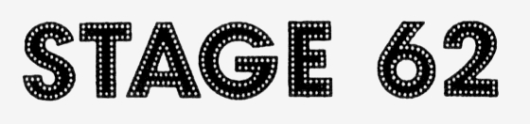
2007 – 2008 Membership Form

___ Voting Member ($15) ___ Associate (Non-Voting) Member ($7)

Name: ________________________________________________________

Address: ________________________________________________________

City/Zip: ________________________________________________________

Phone: (_____)_____________________________Birthday______________

E-mail: ________________________________________________________

Please send my Callboard, the Stage 62 newsletter via:
___ U.S. Mail ___ E-mail (Microsoft Word .doc format)

You can mail this form to P.O. Box 462, Carnegie, PA 15106. Thanks for your support of Stage 62! Remember, we need your time and talents to help make all of our shows a success. Please volunteer as often as you can. | Amt. Rec’d: __________________  Date: _____________________  Paid By: _____________________

2007 – 2008 Membership Form

___ Voting Member ($15) ___ Associate (Non-Voting) Member ($7)

Name: ________________________________________________________

Address: ________________________________________________________

City/Zip: ________________________________________________________

Phone: (_____)_____________________________Birthday______________

E-mail: ________________________________________________________

Please send my Callboard, the Stage 62 newsletter via:
___ U.S. Mail ___ E-mail (Microsoft Word .doc format)

You can mail this form to P.O. Box 462, Carnegie, PA 15106. Thanks for your support of Stage 62! Remember, we need your time and talents to help make all of our shows a success. Please volunteer as often as you can. | Amt. Rec’d: __________________  Date: _____________________  Paid By: _____________________

